############################################

#AFC (reduction) et CAH (regroupement)

############################################

AFC puis classification ascendante hierarchique des quartiers, a partir de leur coordonnees selon les axes factoriels

Utilisation des packages ade4 et FactoClass

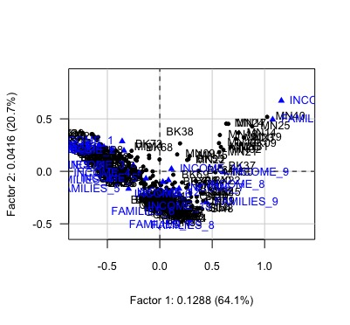**AFC avec la fonction dudi.coa pour pouvoir calculer les distances euclidiennes entre les points**

Resultats de l'AFC stockes dans res.CA2

res.CA2 <- dudi.coa(DATA_ACTIVES, scannf=FALSE, nf=5)

#INCOME_1 Less than $10,000

#INCOME_2 $10,000 to $14,999

#INCOME_3 $15,000 to $24,999

#INCOME_4 $25,000 to $34,999

#INCOME_5 $35,000 to $49,999

#INCOME_6 $50,000 to $74,999

#INCOME_7 $75,000 to $99,999

#INCOME_8 $100,000 to $149,999

#INCOME_9 $150,000 to $199,999

#INCOME_10 $200,000 or more

#INCOME_11 With earnings

#INCOME_12 With Social Security

#INCOME_13 With retirement income

#INCOME_14 With Supplemental Security Income

#INCOME_15 With cash public assistance income

#INCOME_16 With Food Stamp/SNAP bnfts in the past 12 mo

#FAMILIES_1 Less than $10,000

#FAMILIES_2 $10,000 to $14,999

#FAMILIES_3 $15,000 to $24,999

#FAMILIES_4 $25,000 to $34,999

#FAMILIES_5 $35,000 to $49,999

#FAMILIES_6 $50,000 to $74,999

#FAMILIES_7 $75,000 to $99,999

#FAMILIES_8 $100,000 to $149,999

#FAMILIES_9 $150,000 to $199,999

#FAMILIES_10 $200,000 or more

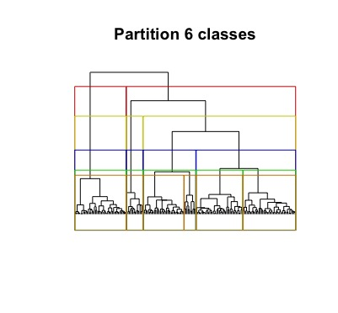**CAH : Calcul de la distance euclidienne entre les lignes**

res.CA2$li

distMat <- dist(res.CA2$li)

distMat

**Classification**

res.CAH <- hclust(distMat, method = "ward.D2")

**Dendogramme**

plot(res.CAH)

names(res.CAH)

plot(sort(res.CAH$height, dec=T)[1:100],type="h")

**Decoupage en 6 groupes et liste des groupes**

groupe.res.CAH <- cutree(res.CAH, k=6)

print(sort(groupe.res.CAH))

**Exporte les quartiers et les groupes dans un fichier csv**

write.table(groupe.res.CAH, file='CAH_20170102.csv', col.names=TRUE, na="", sep=";")

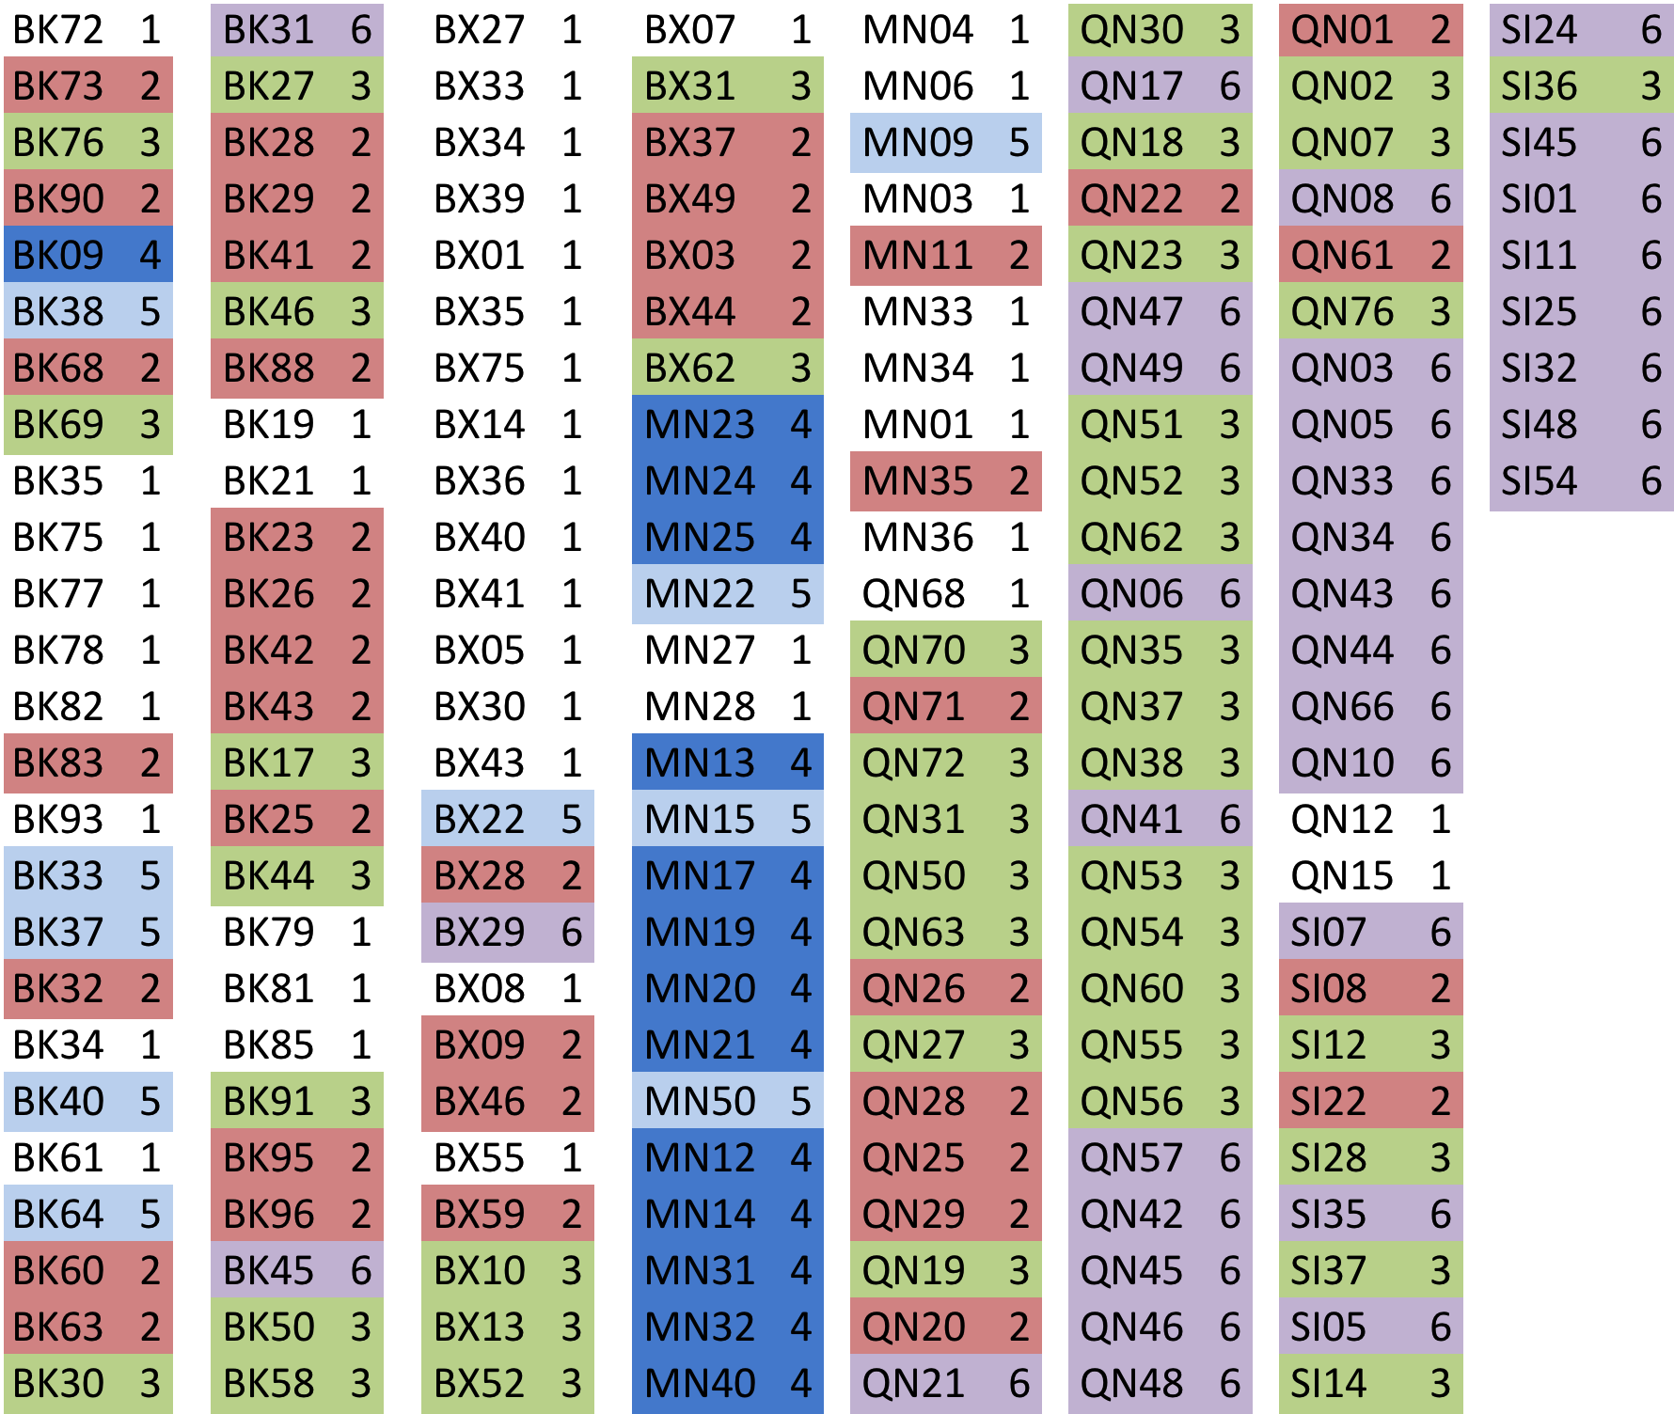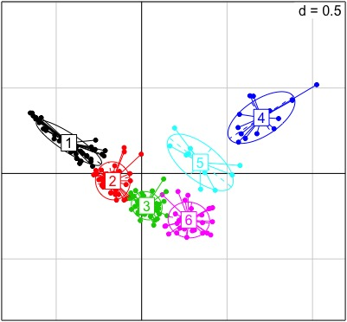

**Fonction de calcul de stats pour comparer les moyennes des variables selon le groupe**.

Calcul des ecarts avec la proportion de variance expliquee.

L'idee est de comparer les moyennes des variables conditionnellement aux groupes.

stat.comp <- function(x,y){

#nombre de groupes

K <- length(unique(y))

#nb. d'observations

n <- length(x)

#moyenne globale

m <- mean(x)

#variabilite totale

TSS <- sum((x-m)^2)

#effectifs conditionnels

nk <- table(y)

#moyennes conditionnelles

mk <- tapply(x,y,mean)

#variabilite expliquee

BSS <- sum(nk * (mk - m)^2)

#moyennes + prop. variance expliquee

result <- c(mk,100.0*BSS/TSS)

#nommer les elements du vecteur

names(result) <- c(paste("G",1:K),"% epl.")

#renvoyer le vecteur resultat

return(result)

}

**Appliquer stat.comp aux variables de la base d'origine DATA_ACTIVES**

sapply(DATA_ACTIVES,stat.comp,y=groupe.res.CAH)

**Opposition des quartiers avec des hauts revenus et des revenus plus modestes qui sont complémentés par des aides**

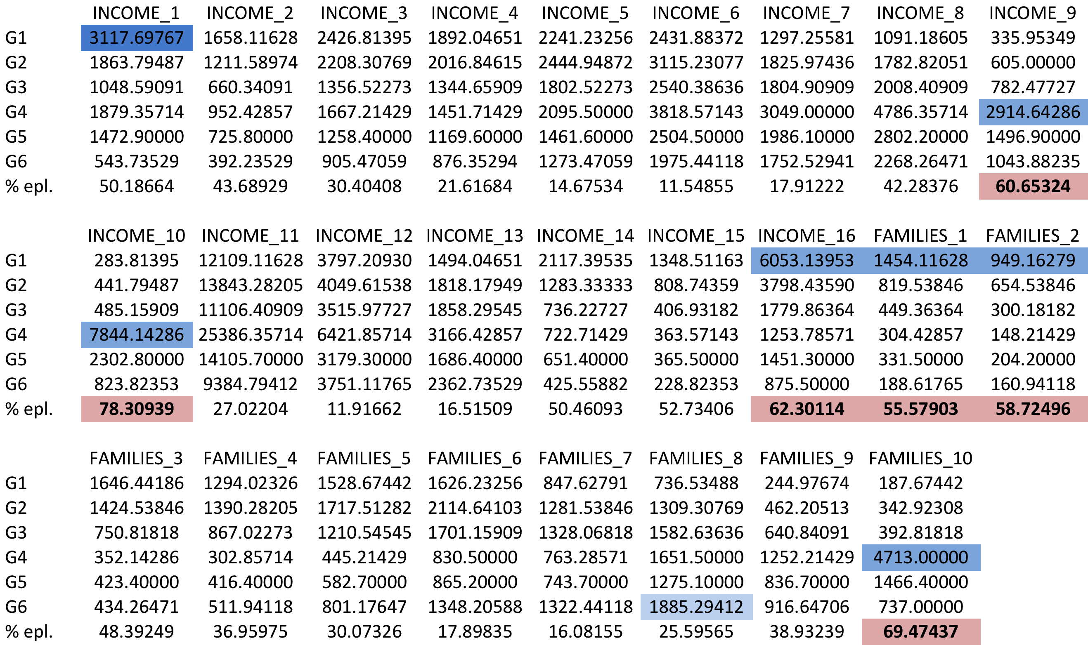

########################Colonnes supplementaires

###LABOUR

#POP_IN_LABOUR_FORCE_CIVIL_EMP : Employed

#POP_IN_LABOUR_FORCE_CIVIL_UNEMP : Unemployed

#POP_IN_LABOUR_FORCE_ARME : Armed Forces

#POP_OUT_LABOUR_FORCE : Not in labor force

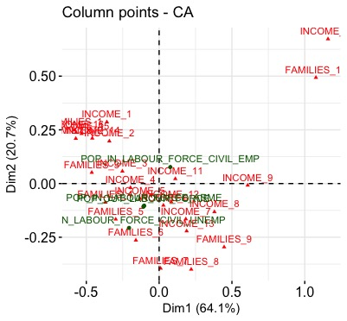

######EMPLOI

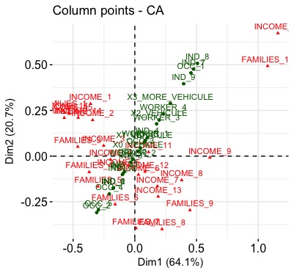#OCC_1 Management, business, science, and arts occupations

#OCC_2 Service occupations

#OCC_3 Sales and office occupations

#OCC_4 Natural resources, construction, and maintenance occupations

#OCC_5 Production, transportation, and material moving occupations

#IND_1 Agriculture, forestry, fishing, hunting, and mining

#IND_2 Construction

#IND_3 Manufacturing

#IND_4 Wholesale trade

#IND_5 Retail trade

#IND_6 Transportation and warehousing, and utilities

#IND_7 Information

#IND_8 Finance and insurance, and real estate and rental and leasing

#IND_9 Professional, scientific, and management, and administrative and waste management services

#IND_10 Educational services, and health care and social assistance

#IND_11 Arts, entertainment, and recreation, and accommodation and food services

#IND_12 Other services, except public administration

#IND_13 Public administration

#WORKER_1 Private wage and salary workers

#WORKER_2 Government workers

#WORKER_3 Self-employed in own not incorporated business workers

#WORKER_4 Unpaid family workers

#0_VEHICLE

#1_VEHICULE

#2_VEHICULE

#3_MORE_VEHICULE

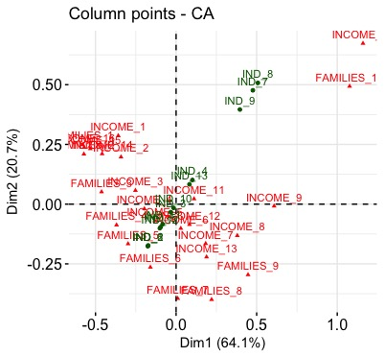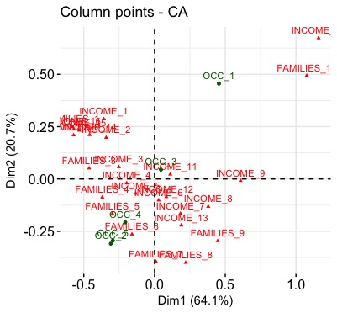

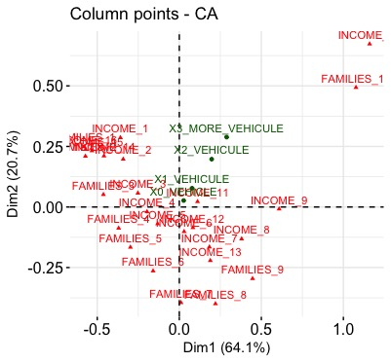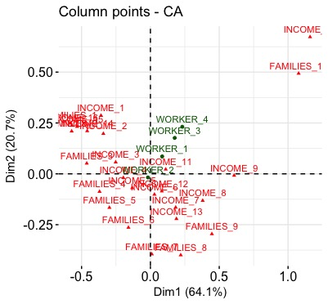

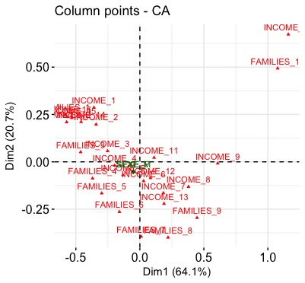######SEXE, AGE ET SITUATION

#SEXE_M Male

#SEXE_F Female

#TR1_AGE Under 5 years

#TR2_AGE 5 to 9 years

#TR3_AGE 10 to 14 years

#TR4_AGE 15 to 19 years

#TR5_AGE 20 to 24 years

#TR6_AGE 25 to 34 years

#TR7_AGE 35 to 44 years

#TR8_AGE 45 to 54 years

#TR9_AGE 55 to 59 years

#TR10_AGE 60 to 64 years

#TR11_AGE 65 to 74 years

#TR12_AGE 75 to 84 years

#TR13_AGE 85 years and over

#RELATION_HOUSEHOLDER Householder

#RELATION_SPOSE Spouse

#RELATION_CHILD Child

#RELATION_OTHER Other relatives

#RELATION_NORELATIVE Nonrelatives

#RELATION_NORELATIVE_UNMARRIED Nonrelatives - Unmarried partner

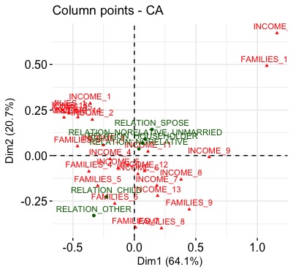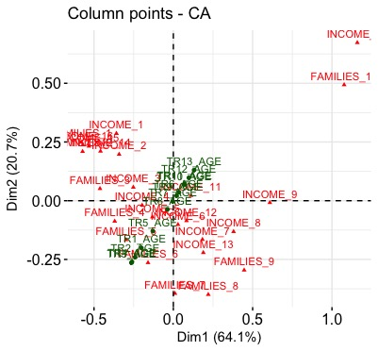

######EDUCATION

#SCHOOL_ENROLLMENT Population 3 years and over enrolled in school

#SCHOOL_BEFORE Nursery school, preschool

#SCHOOL_KINDERGARDEN Kindergarten

#SCHOOL_ELEMENTARY Elementary school (grades 1-8)

#SCHOOL_HIGH High school (grades 9-12)

#SCHOOL_COLLEGE College or graduate school

#EDUC_1 Less than 9th grade

#EDUC_2 9th to 12th grade, no diploma

#EDUC_3 High school graduate (includes equivalency)

#EDUC_4 Some college, no degree

#EDUC_5 Associate's degree

#EDUC_6 Bachelor's degree

#EDUC_7 Graduate or professional degree

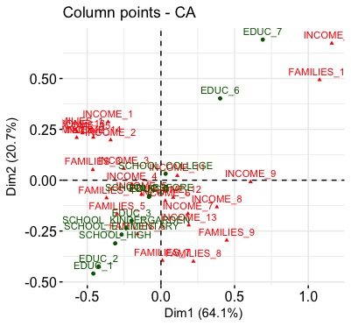

######HOUSING

#OWNER_OCC Owner-occupied

#RENTER_OCC Renter-occupied

#1_UNIT_DET 1-unit, detached

#1_UNIT_ATT 1-unit, attached

#2_UNITS 2 units

#3_4_UNITS 3 or 4 units

#5_9_UNITS 5 to 9 units

#10_19_UNITS 10 to 19 units

#20_MORE_UNITS 20 or more units

#MOBILE_HOME Mobile home

#BOAT_RV_VAN Boat, RV, van, etc.

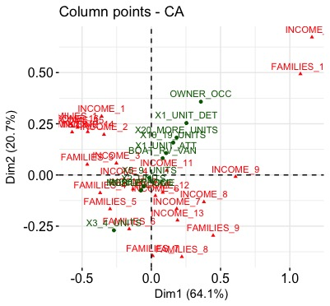

########################Lignes supplementaires

